Grade 6- Physical Education and Health
May 4th, 2020

Dear parents and students, we hope this learning tool kit finds you all well. This week students will have the opportunity to learn about our body image and its impact how it affects us, as well as exploring the poi movements. Some students may already have a poi, if not there are instructions below to make one. Lastly, there is a workout with the Montreal Canadians and a great game of bottle flip tic tac toe.

Learn About Body Image and Get Moving!

Information for students

Activity 1: My body image
Watch the following video to learn more about body image:
- Video: Why Don’t I Like The Way I Look?
What did you learn in the video? Do you think you have a positive body image of yourself? What can you do to adopt a better attitude about your own body image?
Discuss what you learned about body image with a member of your family.

Activity 2: Explore poi movements
Challenge yourself to learn some poi movements. Start with the first lesson. When you can perform the movements well, try the next lesson. Watch the following videos to learn some movements:
- Poi Lesson 1: Start with five movements
- Poi Lesson 2: Try with two hands
- Poi Lesson 3: Ready for more challenge
- Poi Lesson 4: Try to change direction
Now, try to create your own movements or choreograph a routine.
Teach the movements to a member of your family.

Materials required
Device with Internet access
Poi* (or materials to create one)
*NOTE: If you do not have poi at home and you want to make a set of poi, please follow the steps to create your own:
- Document: How to create your own poi
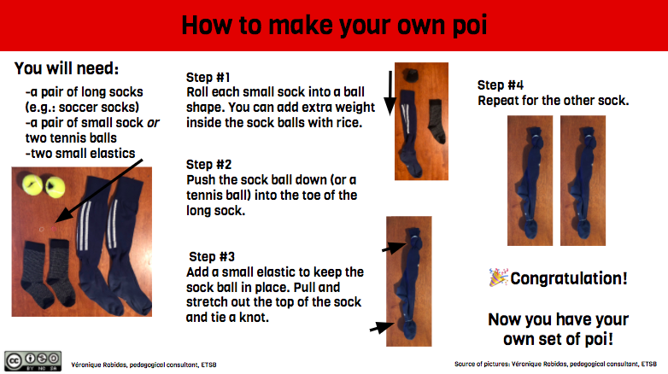

Information for parents

About the activity
Children should:
learn about body image
participate in the proposed physical activities
Parents could:
ask their children questions about what they have learned about body image
discuss the importance of adopting a positive attitude about body image with their children (visit this website for more information about How to Talk About Body Image with children)
try some poi movements with their child

Activity 3: Habs hockey team workout
https://www.nhl.com/canadiens/fans/workouts

Keep active and keep learning. Email and let us know if you are liking the activities and let us know activities you would like to do. Don’t forget that there is still a game of active bottle flip tic tac toe game below.

Stay Safe and Healthy, Miss you all,
Mr. M dmccarthy@emsb.qc.ca, Ms. Quinn tquinn@emsb.qc.ca

Activity 4:
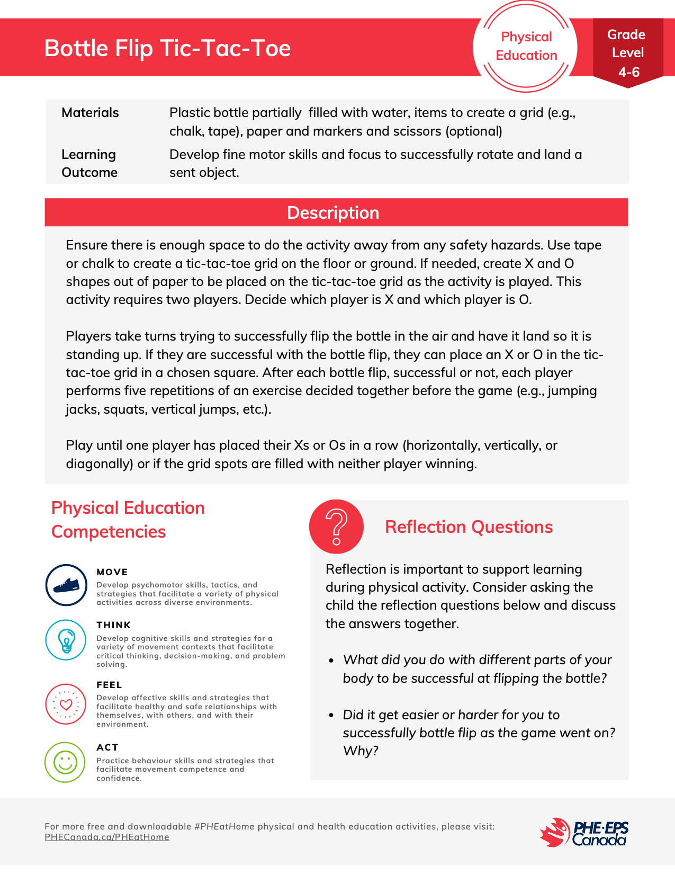
Reference: https://phecanada.ca/sites/default/files/content/docs/Home%20Learning%20Resource/4-6/Physical%20Education/4-6%20PE%20Round%202_Bottle%20Flip%20Tic-Tac-Toe.pdf

