Technology Activity week 4!

Thank you to everyone who sent me a presentation last week. I loved seeing what you guys are up to and they made my week.

This week we will be doing an activity on Scratch.
In case you missed the instructions on a previous week on how to get Scratch, I will repost them below.
- There are TWO WAYS to use Scratch. The first is going to Scratch website, https://scratch.mit.edu/ and then go to “CREATE”. You can save your work by either creating an account and your work will be saved there, OR simply do File: save to your computer and file will be found in your downloads folder.
- Another option is to download Scratch desktop. That means the Scratch program will always be on your computer and you will no longer need internet to use it. You can also save to any place on the computer that you prefer. https://scratch.mit.edu/download

- Once you are on Scratch, go to “Tutorials.”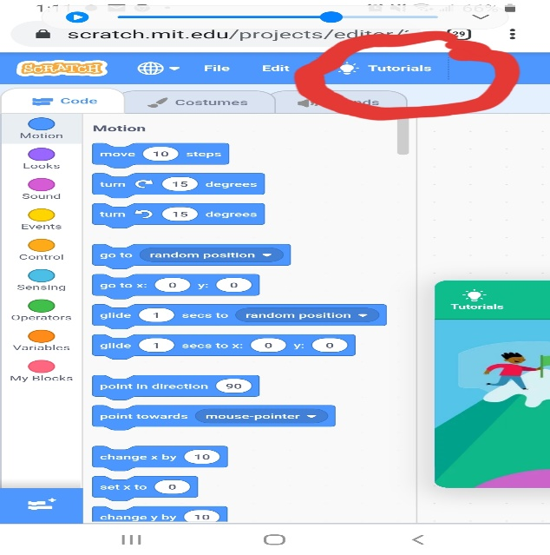
- Go to tutorial “Make it Fly.” 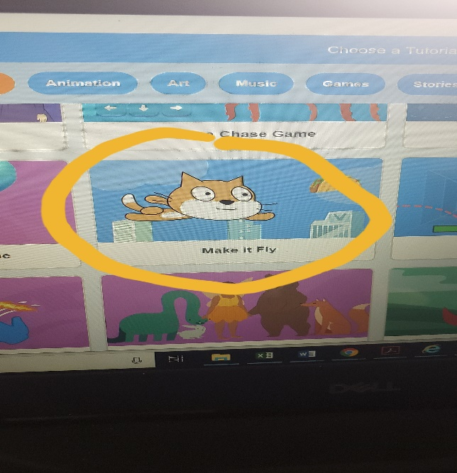
- The tutorial will show you how to make a sprite fly across your screen on a loop, and by the end of the tutorial how to incorporate it into a game. You can either follow the tutorial completely, or make it your own! Have a flying sprite in a story, use it for your own game, etc.

This is a fun tool to use so show me what you can do!
As always all work and questions can be sent to kboyer@emsb.qc.ca or GOOGLE CLASSROOM.

